LAPORAN AKHIR Mobile Computing

Aplikasi Rumus Matematika



oleh:

Sutamri Hapu Mbayu (140403010041)

FAKULTAS SAIN DAN TEKNOLOGI

UNIVERSITAS KANJURUHAN MALANG

2016

Daftar Isi

1. Main_activity.java
2. Activity.xml
3. Script
4. Screenshot
5. Segitiga.java
6. Script
7. Screenshot
8. Segiempat.java
9. Script
10. Screenshot
11. Lingkaran.java
12. Script
13. Screenshot
14. Main_Activity.java
15. Script

package fti.unikama

import android.os.Bundle;

import android.app.Activity;

import android.content.Intent;

import android.view.Menu;

import android.view.View;

public class MainActivity extends Activity {

@Override

protected void onCreate(Bundle savedInstanceState) {

super.onCreate(savedInstanceState);

setContentView(R.layout.activity_main);

}

public void klikPage1(View v){

Intent isegitiga = new Intent (this,segitiga.class);

startActivity (isegitiga);

}

public void klikPage2(View v){

Intent isegiEmpat = new Intent (this,segiempat.class);

startActivity (isegiEmpat);

}

public void klikPage3(View v){

Intent iLingkaran = new Intent (this,lingkaran.class);

startActivity (iLingkaran);

}

public void klikPage4 (View v){

Intent ipersegipanjang = new Intent (this,persegipanjang.class);

startActivity(ipersegipanjang);

}

@Override

public boolean onCreateOptionsMenu(Menu menu) {

// Inflate the menu; this adds items to the action bar if it is present.

getMenuInflater().inflate(R.menu.main, menu);

return true;

}

}

1. Activity.xml
2. Screenshot

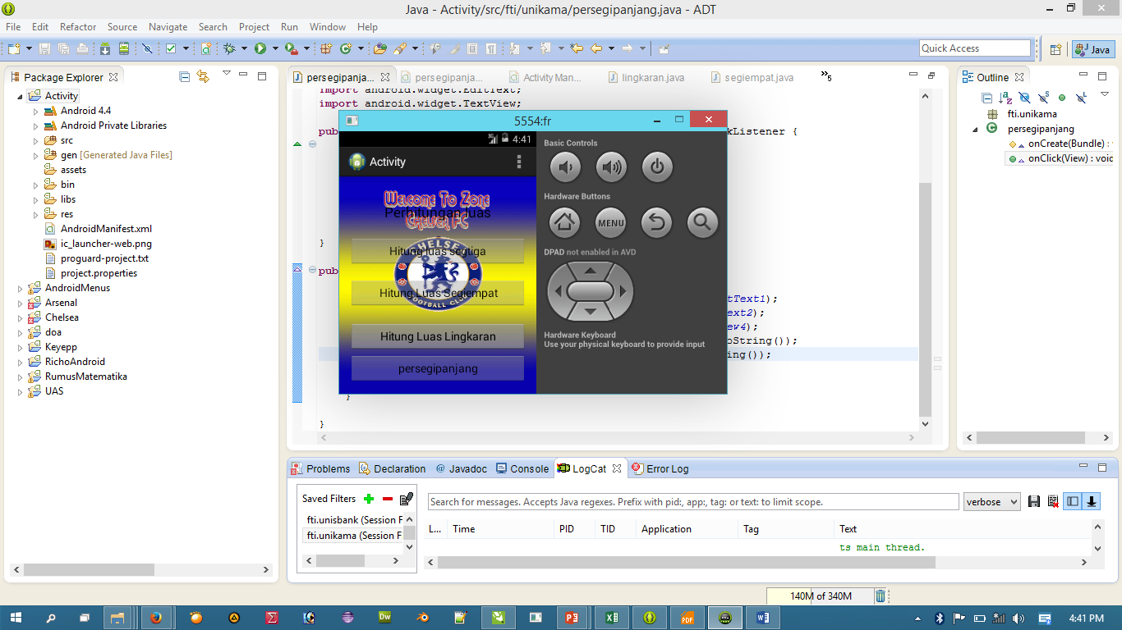

1. Script

<RelativeLayout xmlns:android=*"http://schemas.android.com/apk/res/android"*

xmlns:tools=*"http://schemas.android.com/tools"*

android:layout_width=*"wrap_content"*

android:layout_height=*"match_parent"*

android:paddingBottom=*"@dimen/activity_vertical_margin"*

android:paddingLeft=*"@dimen/activity_horizontal_margin"*

android:paddingRight=*"@dimen/activity_horizontal_margin"*

android:paddingTop=*"@dimen/activity_vertical_margin"*

tools:context=*".MainActivity"*

android:background=*"@drawable/welcome"* >

<TextView

android:id=*"@+id/textView1"*

android:layout_width=*"wrap_content"*

android:layout_height=*"wrap_content"*

android:layout_alignParentTop=*"true"*

android:layout_centerHorizontal=*"true"*

android:layout_marginTop=*"27dp"*

android:text=*"@string/judul"*

android:textAppearance=*"?android:attr/textAppearanceLarge"* />

<Button

android:id=*"@+id/button1"*

android:layout_width=*"match_parent"*

android:layout_height=*"wrap_content"*

android:layout_below=*"@+id/textView1"*

android:layout_centerHorizontal=*"true"*

android:layout_marginTop=*"24dp"*

android:onClick=*"klikPage1"*

android:text=*"@string/segitga"* />

<Button

android:id=*"@+id/button2"*

android:layout_width=*"match_parent"*

android:layout_height=*"wrap_content"*

android:layout_alignLeft=*"@+id/button1"*

android:layout_below=*"@+id/button1"*

android:layout_marginTop=*"20dp"*

android:onClick=*"klikPage2"*

android:text=*"@string/segiempat"* />

<Button

android:id=*"@+id/button3"*

android:layout_width=*"match_parent"*

android:layout_height=*"wrap_content"*

android:layout_alignLeft=*"@+id/button2"*

android:layout_below=*"@+id/button2"*

android:layout_marginTop=*"22dp"*

android:onClick=*"klikPage3"*

android:text=*"@string/lingkaran"* />

<Button

android:id=*"@+id/button4"*

android:layout_width=*"match_parent"*

android:layout_height=*"wrap_content"*

android:layout_alignLeft=*"@+id/button2"*

android:layout_below=*"@+id/button2"*

android:layout_marginTop=*"22dp"*

android:onClick=*"klikPage4"*

android:text=*"@string/lingkaran"* />

<Button

android:id=*"@+id/button5"*

android:layout_width=*"match_parent"*

android:layout_height=*"wrap_content"*

android:layout_alignLeft=*"@+id/button2"*

android:layout_below=*"@+id/button2"*

android:layout_marginTop=*"74dp"*

android:onClick=*"klikPage5"*

android:text=*"@string/persegipanjang"*

/>

</RelativeLayout>

1. Segitiga.java
2. Script

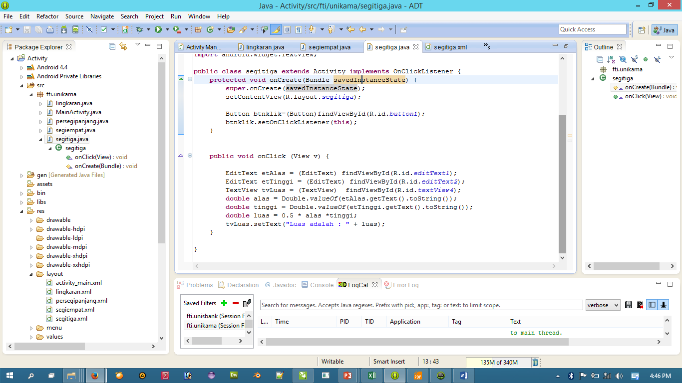

1. Screen Shot

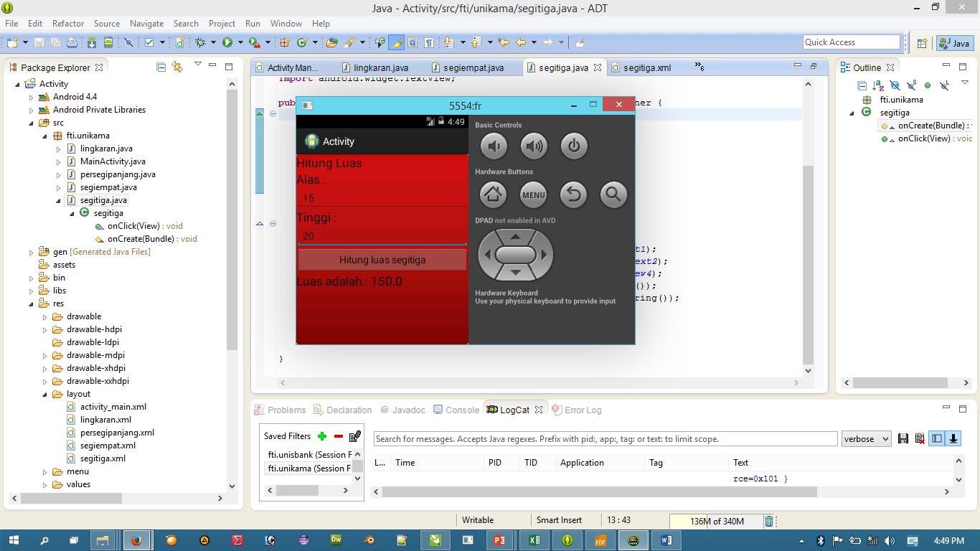

1. Segiempat.java
2. Screenshot

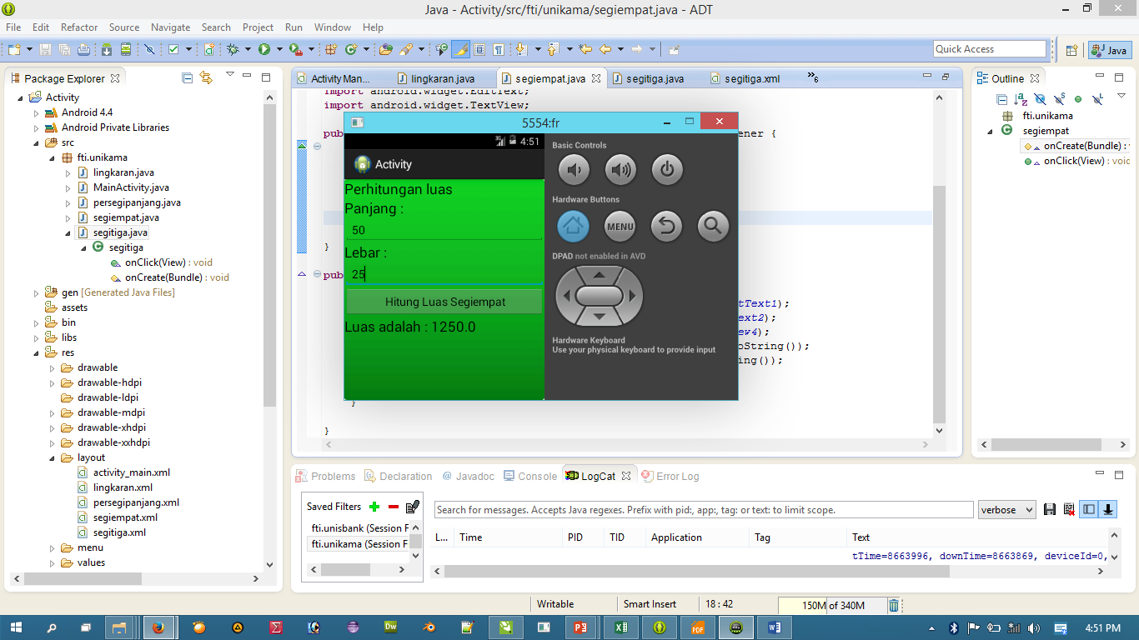

1. Script

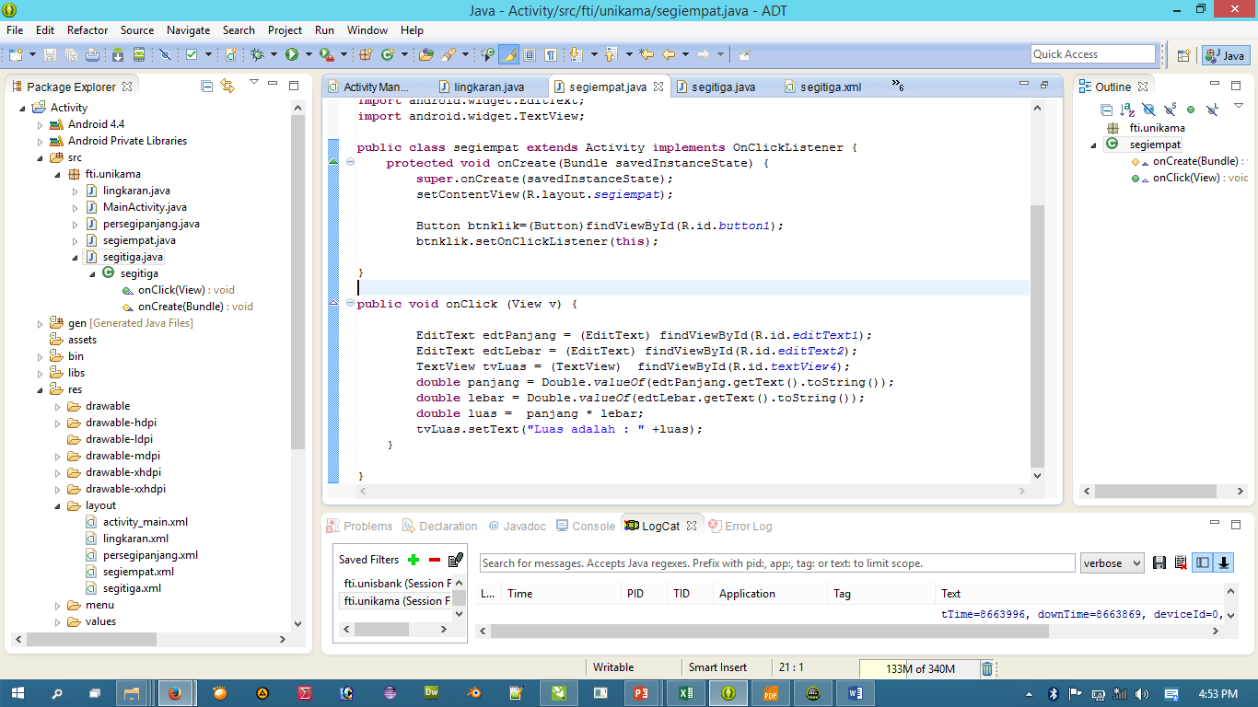

## Lingkaran.java

1. Screenshot

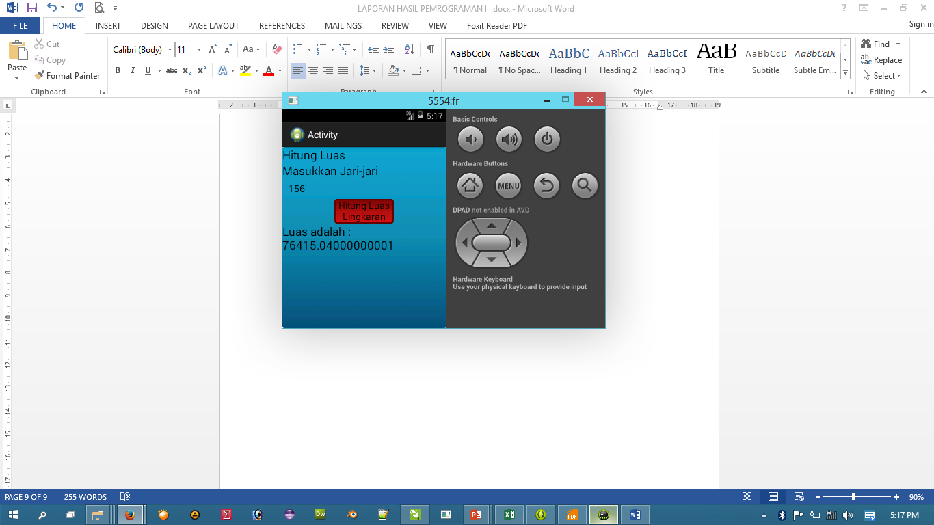

1. Script

